-: EXPERIMENTS :--

EXPERIMENT NO: Zero Lab

Aim: To familiarize students with the Microsoft Power BI environment, installation process, interface, and basic workflow for Business Intelligence and Data Visualization.

Prerequisite:

Microsoft Power BI Desktop installed

Sample Excel dataset (e.g., SalesData.xlsx)

Introduction to Business Intelligence (BI)

Business Intelligence (BI) is the process of collecting, transforming, analyzing, and visualizing data to support informed decision-making. BI tools help organizations convert raw data into meaningful insights through interactive reports and dashboards.

What is Microsoft Power BI?

Power BI is a Business Intelligence and Data Visualization tool developed by Microsoft that enables users to:
Connect to multiple data sources
Transform and clean data
Create interactive visualizations
Build dashboards and reports
Share reports using Power BI Service

Components of Power BI
- Power BI Desktop – Develop reports and dashboards.
- Power BI Service – Publish, share, and collaborate on reports in the cloud.
- Power BI Mobile – Access reports and dashboards from smartphones and tablets.
- Power Query Editor – Import, clean, and transform data from multiple sources.
- DAX (Data Analysis Expressions) – Perform calculations, create measures, and implement business logic.
Power BI Workflow
Data Sources
│
▼
Power Query Editor
(Data Cleaning & Transformation)
│
▼
Power BI Desktop
(Data Modeling + DAX + Report Creation)
│
▼
Power BI Service
(Publish, Share, Refresh, Collaborate)
│
▼
Power BI Mobile
(View Reports Anywhere)

Power BI Workflow
Connect Data
Transform Data
Create Data Model
Build Visualizations
Create Dashboard
Publish and Share

Part A: Installation
- Download Microsoft Power BI Desktop.
- Install the software.
- Launch Power BI Desktop.

Part B: Explore the Interface
Identify the following components:
- Home Ribbon
- Report View
- Data View
- Model View
- Fields Pane
- Visualizations Pane
- Filters Pane
- Power Query Editor

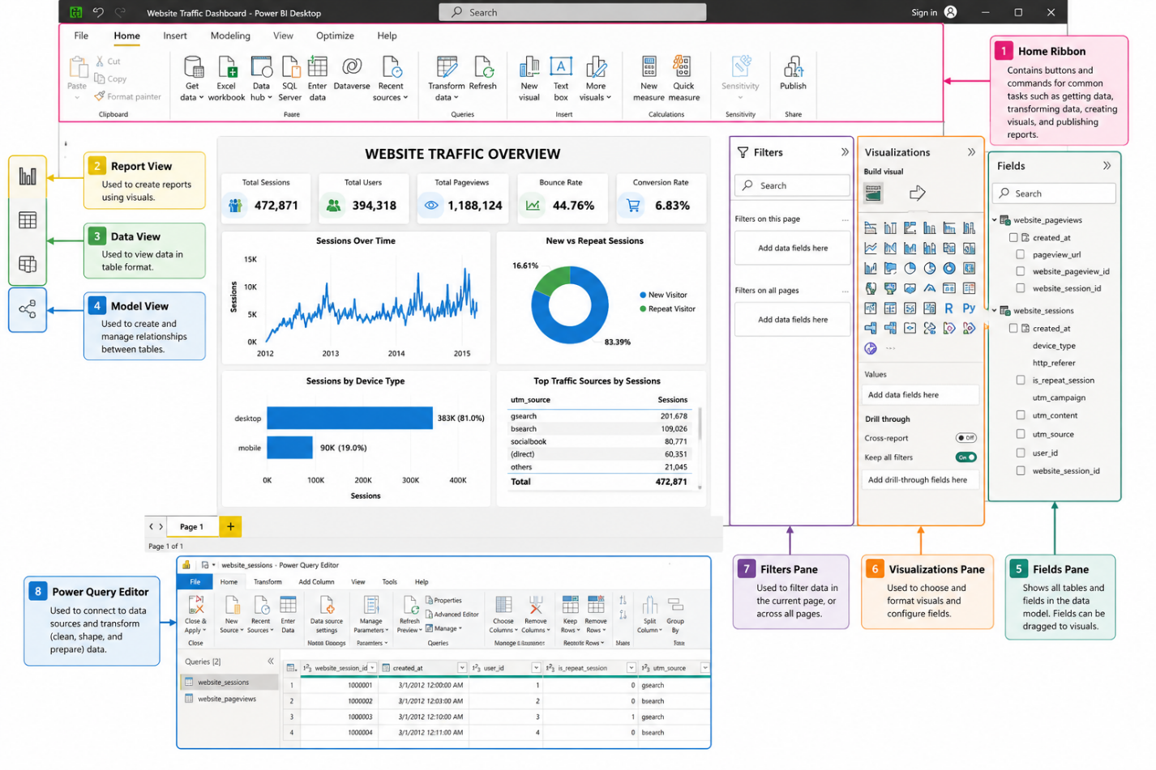

Outcome: Students will be able to:

Install and configure Power BI Desktop.

Navigate the Power BI environment.

Viva Questions:
- What is Business Intelligence?
- What is Microsoft Power BI?
- Differentiate between Power BI Desktop and Power BI Service.
- What are the three main views available in Power BI Desktop?
- What is the difference between a report and a dashboard?
- List the major components of the Power BI ecosystem.

Use Cases:
1. Sales Analytics
- Monitor sales performance by region, product, and salesperson.
- Identify top-selling products and low-performing areas.
- Forecast future sales trends.
2. Healthcare Analytics
- Monitor patient admissions and discharge rates.
- Track hospital occupancy and resource utilization.
- Analyze disease trends and treatment outcomes.

EXPERIMENT NO: 1

Aim: To familiarize students with the Power BI Desktop environment by importing data from different file formats, connecting to data sources, and loading the data for analysis and visualization.

Prerequisite:

Microsoft Power BI Desktop installed.

Basic knowledge of databases and spreadsheets.

Sample datasets in CSV and Excel formats.

Pedagogy Used:

Demonstration Method: The instructor demonstrates how to install, launch, and navigate Power BI Desktop, and how to import data from different file formats.

Hands-on Learning: Students perform each step themselves, including importing datasets, exploring the interface, and opening Power Query Editor.

Experiential Learning: Students learn by interacting with real-world datasets and observing how Power BI handles different data sources.

Problem: Getting Started with Power BI Software Using Data File Formats and Connecting with Power BI

Solution:

Part A: Launch Power BI Desktop
- Open Microsoft Power BI Desktop.
- Wait until the Home screen appears.

Part B: Import a CSV File
- Click Home → Get Data.
- Select Text/CSV.
- Browse and select the dataset (e.g., website_sessions.csv).
- Click Open.
- Preview the data.
- Click Load.

Part C: Import an Excel File
- Click Home → Get Data.
- Select Excel Workbook.
- Browse to the Excel file.
- Select the worksheet(s).
- Click Load.

Part D: View Imported Data

Click Data View.

Verify that the tables are loaded successfully.

Check the number of rows and columns.

Verify the data types of each column.

Part E: Open Power Query Editor
- Click Home → Transform Data.
- Observe the Power Query Editor window.
- Review the applied steps in the Query Settings pane.
- Close the editor without making changes.

Part F: Save the Project
- Click File → Save As.
- Save the project as Experiment1.pbix.

Outcome:

Successfully imported CSV and Excel datasets.

Data displayed correctly in Data View.

Power Query Editor opened successfully.

Power BI project saved as a .pbix file.

Viva Questions:

What is Power BI?

Who developed Power BI?

What is the purpose of Power BI?

What is Business Intelligence (BI)?

Name the main components of the Power BI ecosystem.

What is the difference between Power BI Desktop and Power BI Service?

What is the purpose of Power BI Mobile?

What is a .pbix file?

Which file formats can be imported into Power BI?

What is the purpose of the Get Data option?

How do you import a CSV file into Power BI?

How do you import an Excel workbook into Power BI?

What is Power Query Editor?

Why is data transformation important before analysis?

What is the difference between Load and Transform Data?

Use Cases:
- Retail Sales Analysis – Import sales data from Excel or CSV files to analyze revenue, profits, and customer purchasing trends.
- Student Performance Dashboard – Connect student marks data to monitor academic performance, attendance, and pass percentages.
- Hospital Management – Analyze patient records, treatment history, and resource utilization for better healthcare decisions.

